DAILY ONLINE ACTIVITIES SUMMARY

|  |  |  |  |  |  |  |  |
| --- | --- | --- | --- | --- | --- | --- | --- |
| **Date:** | **12/06/2020** | | | | **Name:** | **Kavya.R.Shetty** | |
| **Sem & Sec** | **VI , A sec** | | | | **USN:** | **4AL17CS042** | |
| Online Test Summary | | | | | | | |
| **Subject** | |  | | | | | |
| **Max. Marks** | |  | | **Score** | |  | |
| Certification Course Summary | | | | | | | |
| **Course** | **Python for Data Science** | | | | | | |
| **Certificate Provider** | | | **COGNITIVE CLASS IBM** | **Duration** | | | **7 hrs** |
| Coding Challenges | | | | | | | |
| **Problem Statement:**   1. Write a Python program to implement Magic Square 2. Python program to print the pattern 3. Write a Java program to find maximum width of a binary tree | | | | | | | |
| **Status: Completed** | | | | | | | |
| **Uploaded the report in Github** | | | | **Yes** | | | |
| **If yes Repository name** | | | | <https://github.com/kavya-shetty765/DAILY-> [STATUS](https://github.com/nandithashetty/DAILY-STATUS) | | | |
| **Uploaded the report in slack** | | | | **Yes** | | | |

# Certification course Details:

**Python for Data Science:**

Today I learnt **Module 1**

In that I learnt about these topics,

* Types
* Expressions and Variables
* String Operations

Refer GitHub account for Detailed information:

<https://github.com/kavya-shetty765/DAILY-STATUS/tree/master/12-06-> [2020/CERTIFICATION%20COURSE](https://github.com/nandithashetty/DAILY-STATUS/tree/master/12-06-2020/CERTIFICATION%20COURSE)

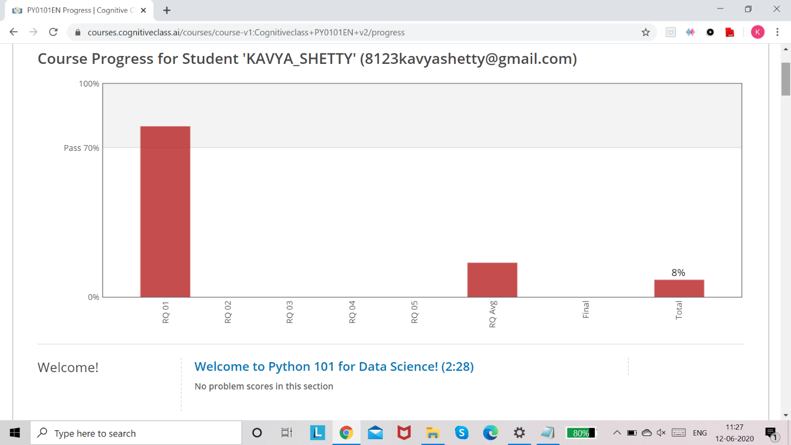

# Coding Challenge Details:

Refer the GitHub for Detailed Information:

<https://github.com/kavya-shetty765/DAILY-STATUS/tree/master/12-06-> [2020/ONLINE%20CODING](https://github.com/nandithashetty/DAILY-STATUS/tree/master/12-06-2020/ONLINE%20CODING)

The same report is also available in :

<https://github.com/kavya-shetty765/DAILY-STATUS/tree/master/12-06-2020>